User manual OSCIPLOT_GUI.m

Osciplot_gui is a GUI that facilitates the construction of movies from analog data (sampled trace and stimulus). In this movies, the visual of a oscillator is somewhat simulated, as the film actually runs over the signal, but the frame ‘pauses’ as it passes by a peak above a certain threshold. In the GUI, some tools are inserted to change the movie parameters and condition the signal.

Use:

To use the GUI, call the function osciplot_gui.m. it expects a certain input:

osciplot_gui expects this input:

'experiment',recording number,channel,condition,[repetitions]).

e.g. osciplot_gui('G17512',6,1,1,[1:10])

Once the GUI is launched, the signal and the movie parameters can be adapted from this GUI itself. Once all the frames are collected, a preview of the movie can be obtained. Finally, the movie can be saved under a certain name at a certain position on the computer. A short overview of the different parts on the gui:

1. Data info

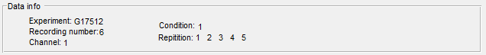

Completely at the top of the GUI, a display of the used data is given

1. Filter parameters

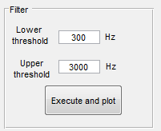

Insert values for the needed filter parameters and a filter execution button

1. Y-limits movie display

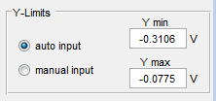

If the y-limits are set on auto input, the limits used in the movie are the max and min occurring y-values in the signal (and the frames are fixed on this). In some cases, e.g. in the presence of large artefacts in the signal, it can be interesting to manually set the limits. Then ‘manual input’ should be chosen and the wanted limits inserted.

1. Peak detection

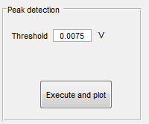

The threshold value for the peak triggering can be inserted here. If the value is changed, execution is needed again.

1. Window size selection

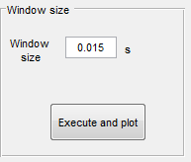

Selection of window size for the movie frames. If the value is changed, execution is needed again.

1. Movie parameters

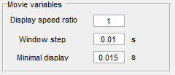

These parameters are directly influencing the movie.

-The display speed ratio is the ratio between the speed at which the signal in the movie is played and the real signal speed. If Display speed ratio = 0.5, the movie will be go 2 times slower than the real signal.   
-The window step is the stepsize at which the frames go over the signal. Since the steps of the samples are really small, it is interesting to make larger steps.   
- The minimal display time is the minimal time the movie shows a peak (that is above the threshold).

7) Audio selection

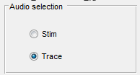

For the audio in the movie, the stimulus as well as the trace can be used.

1. Execute and preview

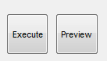

As the execute button is pressed, all the frames of the movie are made and put along each other. This is the most time consuming step in the process, and depending on the signal length and the selected movie parameters it can take some time. Once the execution is finished, a preview of the movie can be seen. Here the movie is showed at the actual speed but without the audio.

1. File characteristics

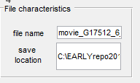

Here the file name of the movie and the location on the computer where it is saved can be chosen. Please make sure the both these input are valid.

1. Save the movie

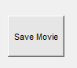

By pressing this button, the constructed movie is saved under the given file name at the chosen location.

Code:

The main file is **osciplot_gui.m** and from here all the other files and functions are called. The largest part of this file is auto generated code from the GUI **osciplot_gui.fig**. From this latter (once opened with GUIDE in matlab) everything in osciplot_gui.m can be easily found. Just press right mouse button on something (a text window or a button) on the gui and you can go directly to the edit or callback function of this in osciplot_gui.m.

From osciplot.m, all the other functions (stored in the different files) are called. Every function starts with a couple of assert to check if the input makes sense and a warning window will pop up if not. A short overview of the different files and their function:

- **init_gui.m**: Initialize all the values and signals used in the gui.

- **filter_and_plot.m**: Filters the signal and plots the result on the gui.

- **peakfinder_and_plot.m**: Stores all the positions of the peaks that are higher than the inserted threshold value and also plots the result on the gui.  
  
- **windowsize_and_plot.m**: Selection of the window size used for the frames of the movie. A preview for the first selected peaks is given in an external plot.

- **get_frames.m**: Saves all the frames (for stim and trace) for the video and also for the audio track.

- **save_movie**: saves all the movie frames and couples it the audio frames.